**Sprint 3 Report**

Sprint duration: April 4, 2021 – April 29, 2021

Number of working days in a sprint: 1 month

Team Members:

Sapan Sharma (6352819), Alanna McNulty (6275168), Alexander Bowles (6089957),

Arooj Fateh (6246185), Alex Orvitz (5517693), Samantha Laffin (5017538), Brian Jenkins (6063481)

**Sprint Backlog**

|  |  |  |  |
| --- | --- | --- | --- |
| **Item Description** | **Sub-Task Description** | **Team Member(s)** | **Progress** |
| Home Page | Show a list of posts | Alex Orvitz | Complete |
| Interact with posts | Alex Orvitz | Complete |
| Test implemented functionality | Alex Orvitz | Complete |
|  |  |  |
| Login Functionality | Login UI | Brian Jenkins | Complete |
| Login backend | Sapan Sharma | Complete |
| Login Security | Sapan Sharma | Complete |
| JUnit Test Implemented | Brian Jenkins | Complete |
|  |  |  |
| Profile Page | User profile UI | Arooj Fateh | Complete |
| User profile mapping from database | Arooj Fateh | Complete |
| User updating profile information | Arooj Fateh | Complete |
| Other profile options | Arooj Fateh | Complete |
| Test implemented functionality | Arooj Fateh | Complete |
|  |  |  |
| Navigation  Component |  | Alex Orvitz | Complete |
|  |  |  |
| Sign Up | Sign up UI | Brian Jenkins | Complete |
| Sign up Backend | Sapan Sharma | Complete |
| Sign up Methods | Brian Jenkins | Complete |
| Sign up Security | Brian Jenkins | Complete |
|  |  |  |
| Location Map Integration | Map UI | Brian Jenkins | Removed |
| Map placement | Brian Jenkins | Removed |
| Location permissions | Sapan Sharma | Removed |
| Test implemented functionality | Sapan Sharma | Removed |
|  |  |  |
| NPO Information Page | NPO UI | Alanna McNulty | Complete |
| NPO profile mapping from database | Alanna McNulty | Complete |
| NPO updating profile information | Alanna McNulty | Complete |
| Other profile options | Alanna McNulty | Complete |
| Test implemented functionality | Alanna McNulty | Complete |
|  |  |  |
| Firebase Setup and Management | Firebase Console management | Sapan Sharma | Complete |
| Firebase dependency management | Sapan Sharma | Complete |
| Firebase consistency across project | Sapan Sharma | Complete |
| Firebase image storage and retrieval | Sapan Sharma | Complete |
| Test implemented functionality | Sapan Sharma | Complete |
|  |  |  |
| Past Donation/  Favourites Page | Page UI | Alexander Bowles | Complete |
| Show list of past donations | Alexander Bowles | Complete |
| Show list of favourites page | Alexander Bowles | Complete |
| Map according to logged in user | Alexander Bowles | Complete |
| Test implemented functionality | Alexander Bowles | Complete |
| ‘Add to favourites’ button added | Alexander Bowles | Complete |
|  |  |  |
| Create Post Page | Create post UI | Arooj Fateh | Complete |
| Create fields rules to upload post | Arooj Fateh | Complete |
| Update firebase database | Arooj Fateh | Complete |
| Test implemented functionality | Arooj Fateh | Complete |
|  |  |  |
| Multiple User Permission Settings and Rules | Separating user classes and access | Sapan Sharma | Complete |
| Create admin level access | Sapan Sharma | Complete |
| Create donor level access | Sapan Sharma | Complete |
| Create NPO level access | Sapan Sharma | Complete |
| Create receiver level access | Sapan Sharma | Complete |
| Test implemented functionality | Sapan Sharma | Complete |
|  |  |  |
| Notifications | Push notification functionality enabled | Sam Laffin | Complete |

**Product Backlog**

|  |  |  |  |
| --- | --- | --- | --- |
| **Item ID** | **Item Description** | **Team Member(s)** | **Progress** |
| DON-18 | Home Page | Alex Orvitz | Complete |
| DON-16 | Login Functionality | Brian Jenkins | Complete |
| DON-19 | Profile Page | Arooj Fateh | Complete |
| DON-29 | Navigation Component | Alex Orvitz | Complete |
| DON-15 | Sign Up | Brian Jenkins | Complete |
| DON-20 | NPO Information Page | Alanna McNulty | Complete |
| DON-23 | Firebase Setup and Management | Sapan Sharma | Complete |
| DON-28 | Past Donation/Favourites Page | Alexander Bowles | Complete |
| DON-25 | Create Post Page | Arooj Fateh | Complete |
| DON-17 | Multiple User Permission Settings and Rules | Sapan Sharma | Complete |
| DON-22 | Search Engine & Filters | Alex Orvitz | Complete |
| DON-24 | UI improvements and Design | Alanna McNulty, Alexander Bowles | Complete |
| DON-27 | Location map integration | Brian Jenkins, Sapan Sharma | Removed |
| DON-26 | Notifications | Sam Laffin | Some Types Removed |
| DON-21 | Chat Interface | Brian Jenkins | Removed |

**Monitoring Progress Toward Goals**

|  |  |
| --- | --- |
| Item ID | Progress Description |
| DON-29 | Navigation between current pages is complete. |
| DON-23 | ‘In progress’ task is to use the release and monitor functionality of Firebase to manage distribution, performance insights and testing of the app when published. |
| DON-17 | Separation of user roles along with security rules is completed. The structure of the Firestore database is updated to reflect and enforce these rules. |
| DON-28 | Functionality for adding documents to favourites subcollections for each account currently in progress. |
| DON-20 | The non-profit profile page, and the settings page for non-profits has been finished. |
| DON-26 | Push notifications for a single device have been completed. Additional types of notification have been removed from the specification. |
| DON-19 | Profile page has been finished. |
| DON-15 | Sign-up functionality has been completed to the updated specification provided in the report for Sprint 2. |
| DON-16 | Log-in functionality has been completed to the previous specification.  As a way of ensuring secure transactions between users and the Firestore database, improves security measures have been implemented. Authentication has also undergone rigorous testing with JUnit and with the Firebase Test SDK. |
| DON-21 | The chat interface has been removed from the product specification. |
| DON-27 | Location map integration has been removed from the product specification. |
| DON-25 | Functionality for the user location information has been removed from the product specification. |
| DON-24 | UI has been updated. |

**Removed Items**

|  |  |  |
| --- | --- | --- |
| **Item ID** | **Item Description** | **Description** |
| DON-21 | Chat Interface | Firebase in-app messaging was looked at as a way to implement chatting between users. This feature was removed. If a user wants to contact a non-profit organization, they can do so using the phone or email buttons found on the non-profit’s profile page instead. |
| DON-27 | Location Map Integration | Location map integration was going to be used as a way for search results to be sorted by distance from the user. This feature was removed, however the user is still able to view the location of a non-profit organization via the button on the non-profit’s profile page. The address of the organization is also displayed here. |
| DON-26 | Notifications | Push notifications are enabled. The other types of notifications, via email and text messaging were removed. |

# Current Design Scheme Diagram

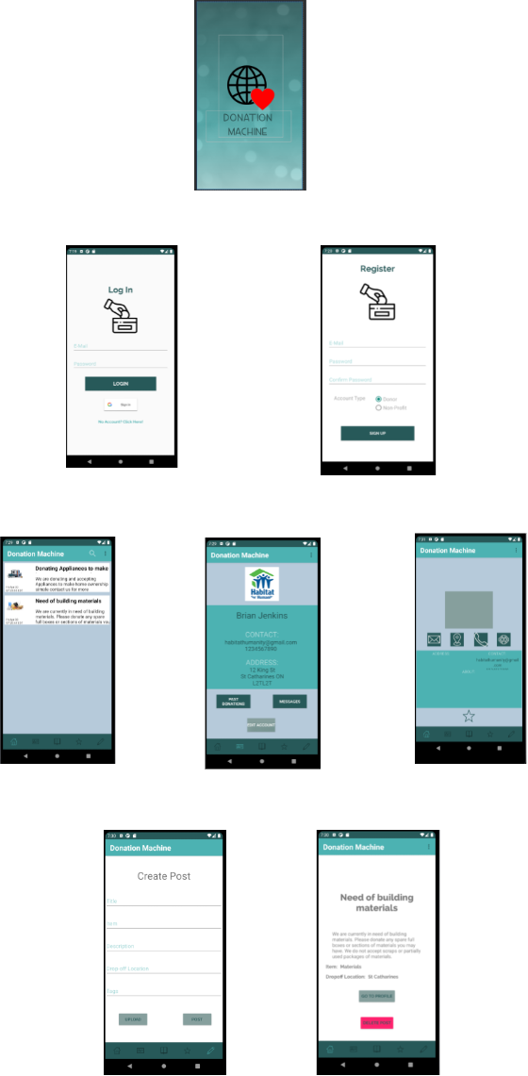

**Integration Testing**

Integration Testing with the Firebase Emulator Suite

The integration testing of our application relies the Firebase Emulator Suite. While unit tests are more concerned with functions that the application handles locally such as screen changes and user interactions. The Firebase Emulator Suite focuses on testing functions that interacts with the user authentication system, the instant messaging service or the non-relational Firestore database.

This tool allows us to run our database calls through a test server which can be installed on our local machines. Each local environment is an empty database consisting only of the structure from our cloud production environment. This lets us test repeatedly run the same tests without having to worry about conflicts.

Sprint 3 Integration Checklist

The integration checklist is a good indicator of which integration tests were completed during this sprint. However, it is important to note that each test case only contains a very high-level description of the work needed to complete each task.

|  |  |  |  |  |
| --- | --- | --- | --- | --- |
| Test Case | Description | Status | Expected Result | Actual Result |
| Sign Up | Allow the user to sign up with their google account or with an email/password combination. | Passed | Firebase authentication entry and Firestore entry created for user. | Performed as expected. |
| Log In | Allow the user to log in with Google or username/password combination. | Passed | Successful firebase authentication with application. | Performed as expected. |
| Create/Delete Post | Allow users and NPOs to publish posts on the home page. | Passed | Updates to the post collection in the logged in userid document in Firestore emulator. | Test results reflected the updates performed. |
| Add/Remove Favorite | Allow users to save a list of NPOs or posts for later viewing. | Passed | Fetch post data from a users favourites subcollection. | Post data was retrieved as expected. |
| Retrieve user profile data | Show user data from the database on the profile page of user or NPO organization | Passed | Fetch sample data stored in Firestore database. | Sample data was fetched exactly as expected. |
| Profile picture upload | Allow the user to upload a picture as a display picture. | Passed | Object location of picture uploaded by user during signup. | Object location from where image can be viewed received. |
| Upload a picture for a post | Allow the user to upload a picture related to the post they are posting. | Passed | Object location of picture uploaded by user during post process. | Object location from where image can be viewed received. |
| Update another user profile | User should only be allowed to update their own profile. | Passed | Security rules enforce update rules. | User unable to update any other profile. |
| Search Platform | Allow the user to query the Firestore database for NPO or other user posts. | Passed | Successful complex query performed | Unsuccessful database query. |

**User Interface Testing**

User Interface Testing with JUnit4 and Espresso

In order to validate that our user interface consistently functions as it should, UI testing was implemented into our application. Using the espresso and JUnit libraries, this testing process leveraged the power of the Android Studio emulator to mimic what a user may do during their time spent on the application. Tests such as user creation, post creation and preference changes were all rigorously tested.

|  |  |  |  |  |
| --- | --- | --- | --- | --- |
| UI Screen | Description | Status | Devices Tested | APIs Tested |
| Sign In Activity | Mimic a user signing in with their email and password | Passed | Pixel 4, Nexus | 30,29 |
| Sign Up and Additional Info Activity | Mimic a user signing up with a random email, password and account type. Followed by the completion of the additional info screen. | Passed | Pixel 4, Nexus | 30,29 |
| Main Activity (Fragment Manager) | Traverse each of the Main Activity Fragments in order to ensure fragments are showing as they should. I.e. correct fragment, no crashes. | Passed | Pixel 4 | 30 |
| Main Activity – Post and Home Fragments | Mimic a user posting an advertisement for their donation needs. Verify that the post has been made by traversing to the home screen before promptly deleting the test post. | Passed | Pixel 4 | 30 |